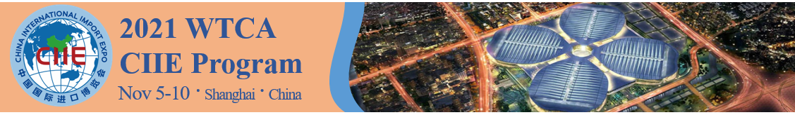
2021 WTCA CIIE PROGRAM - WTC and Company Profiles for Booklet

The following information will be translated and placed in the 2021 WTCA CIIE Booklet, to be distributed in digital and hard-copy forms at CIIE. You are welcome to send additional marketing/promotional materials, such as a brochure, video, flyer, etc. Please note, we will be unable to ship any materials back to you, and we are unable to accept product samples for display.

WTCA Members: there is no limit to the number of member companies you submit for inclusion in the booklet. Deadline for submission is September 17.
World Trade Center or Company
World Trade Center affiliation (if a company)
Country/Region
Industry
Description of how you can serve the Chinese market (400 words max)
Images (please share up to 2 images in JPG or PNG for selection. Please paste into this table or email directly for submission)
Website
Contact Information | Full name:  Title:  Email:

You permit the WTCA to collect and use the information that you provide for the purpose of advertising and promoting your organization. This information will be generally available to participants in the CIIE Program and their partners.

Please submit by Friday, September 17, 2021 to:
Adele Zhang, Program Manager, WTCA Asia Pacific Regional Office (APRO)
Email: azhang@wtca.org

